**DAILY ONLINE ACTIVITIES SUMMARY**

|  |  |  |  |  |  |  |  |  |
| --- | --- | --- | --- | --- | --- | --- | --- | --- |
| **Date:** | **19/05/20** | | | | | **Name:** | **Gulam Rabbani** | |
| **Sem & Sec** | **4th Sem “B” Section** | | | | | **USN:** | **4AL18CS099** | |
| **Online Test Summary** | | | | | | | | |
| **Subject** | | **Design and Analysis of Algorithms** | | | | | | |
| **Max. Marks** | | **30** | | **Score** | | | **9** | |
| **Certification Course Summary** | | | | | | | | |
| **Course** | 1. **Learn Socket Programming in C from Scratch** | | | | | | | |
| **Certificate Provider** | | | **Udemy** | | **Duration** | | | **1:25:00** |
| **Coding Challenges** | | | | | | | | |
| **Problem Statement: Two java programs and 1 C programs** | | | | | | | | |
| **Status: Executed** | | | | | | | | |
| **Uploaded the report in GitHub** | | | | | **Yes** | | | |
| **If yes Repository name** | | | | | **https://github.com/alvas-education-foundation/gulam_rabbani/tree/master/daily_progress** | | | |
| **Uploaded the report in slack** | | | | | **Yes** | | | |

Online Test Details: (Attach the snapshot and briefly write the report for the same)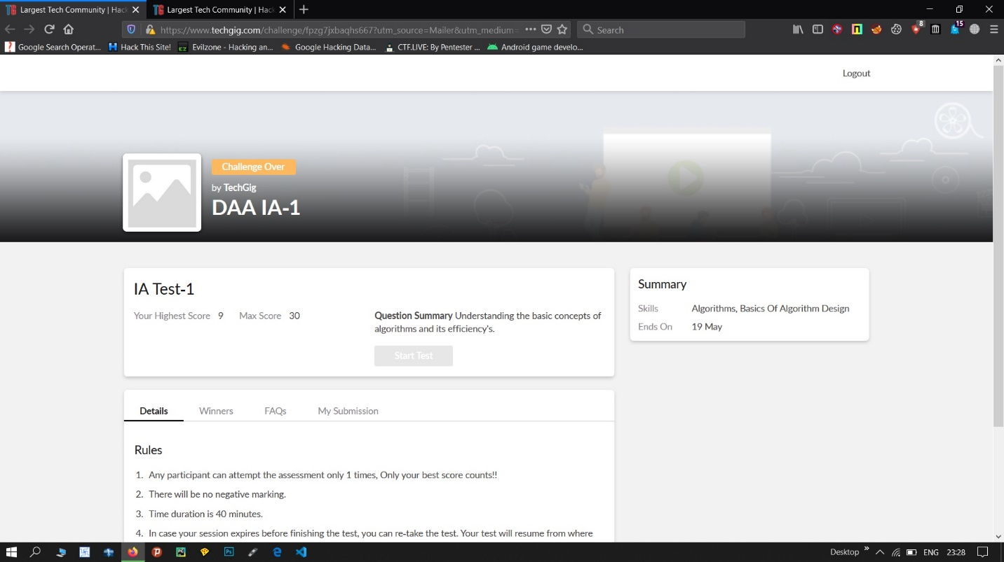

Certification Course Details: (Attach the snapshot and briefly write the report for the same)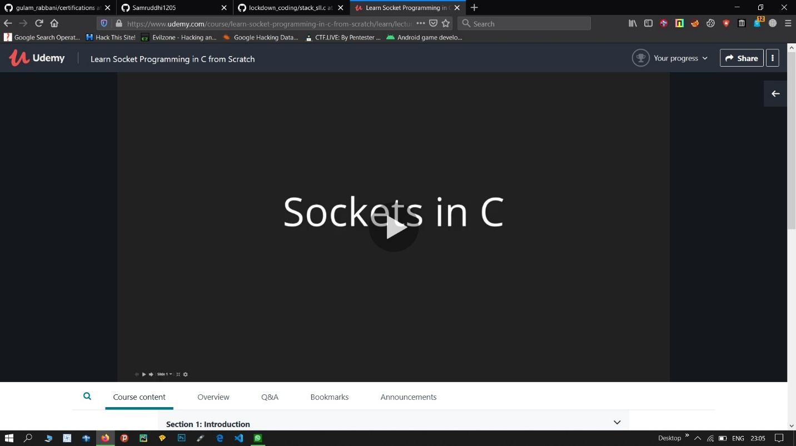

The course will teach:

**Concepts of port communication**

**Sockets and their use**

**Data transfer between systems**

**HTTP protocol**

**Building HTTP server**

**Advance C programming concepts**

Start now and build the next generation C communication Apps.

**What you’ll learn**

* Understand Socket Programming in C
* Learn how to create server and clients and communicate between them
* Learn about TCP programming
* Learn all about HTTP server programming

**Are there any course requirements or prerequisites?**

* Students should have basic knowledge of C before starting this course
* Basic knowledge of Linux

**Who this course is for:**

* Students who want to learn advance socket programming using C

Coding Challenges Details: (Attach the snapshot and briefly write the report for the same)